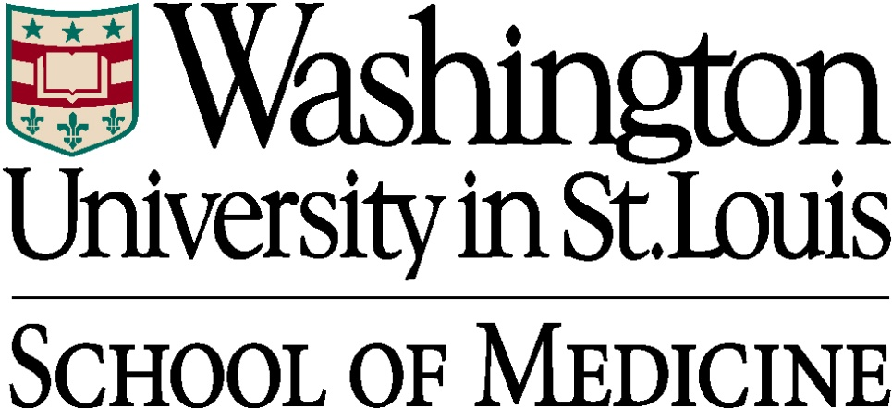

DEPARTMENT of ORTHOPAEDIC SURGERY

SPORTS MEDICINE FELLOWSHIP HANDBOOK
2023-2024



EDUCATIONAL GOALS & OBJECTIVES FOR THE

WASHINGTON UNIVERSITY SPORTS MEDICINE FELLOWSHIP

The mission of the Sports Medicine Division is 1) to deliver the highest quality advanced clinical care for those athletes and individuals with sports or recreation related injuries, 2) to foster and promote innovative clinical and basic science research of sports medicine and soft tissue injury, 3) to provide the residents and fellows of the Department a broadly based education in orthopedic and medical aspects of Sports Medicine, and 4) to promote the development of an appropriate structure to support the clinical, educational, and research endeavors of each member of the Division.

The Sports Medicine Division is composed of five fellowship-trained surgical faculty members with specific interest in and focus on Sports Medicine and sports-related injuries. The Division also includes one fellowship-trained faculty member who specializes in non-surgical management of sports-related injuries and concussion management. The Division employs a multidisciplinary team approach as faculty work closely in conjunction with physical therapists, athletic trainers, physiatrists and rehabilitation medicine specialists, and human performance experts. The Division provides Sports Medicine coverage for a wide range of athletic teams from local high schools to colleges to professional teams. We are the official team physicians for the St. Louis Blues Hockey team, St. Louis City SC MLS professional soccer team, Washington University (Division-III) varsity athletic teams, Lindenwood University (Division-I) varsity athletic teams and numerous high school teams.

The Orthopedic Sports Medicine Division surgical faculty members are: Matthew J Matava, MD, Fellowship Director; Robert H. Brophy, MD; Derrick M. Knapik, MD; Jeffrey Nepple, MD; and Matthew V. Smith, MD:
- Dr. Matava completed his orthopedic surgery residency at Emory University and a fellowship in Sports Medicine at Cincinnati Sports Medicine and Orthopaedic Center. Dr. Matava serves as the Director of the Sports Medicine Fellowship program and is the Medical Director of St. Louis Blues Hockey team and head team physician of the Lindenwood University varsity athletic teams. His areas of clinical interest are knee ligament reconstruction including adult and pediatric primary, revision and multi-ligament reconstruction, meniscal transplantation, articular cartilage reconstruction and issues related to team care.
- Dr. Brophy completed his orthopedic residency and fellowship in sports medicine and shoulder surgery at the Hospital for Special Surgery in New York City. He serves as the Chief of the Sports Medicine Division. He is the Medical Director of the St. Louis City SC soccer team, assistant team physician of the St. Louis Blues Hockey team and team physician of the Washington University Varsity Athletics. His special interests include articular cartilage and ligamentous injuries, shoulder disorders, and injury prevention and treatment of soccer players.
- Dr. Knapik completed his orthopedic residency at University Hospitals Cleveland Medical Center and fellowship in Sports Medicine at Midwest Orthopaedics at Rush University. He is an assistant team physician for Lindenwood University. His special interests are orthobiologics, clinical and basic science research and patient-reported outcome metrics.
- Dr. Nepple completed residency in Orthopaedic Surgery, at Washington University School of Medicine, then went on to complete a fellowship in Sports Medicine at the Steadman Clinic/Steadman-Philippon Research Institute as well as a fellowship in Pediatric Orthopaedics at Washington University School of Medicine. He specializes in pediatric and adolescent sports medicine, and is the Director of the Washington University and St. Louis Children's Young Athlete Center. He has clinical interests in adolescent and young adult hip disorders, including femoroacetabular impingement (FAI), labral tears and slipped capital femoral epiphysis (SCFE) with a specific focus on minimally invasive arthroscopic techniques for the treatment of hip disorders.
- Dr. Smith completed his orthopedic residency at the University Hospitals of Cleveland Case Western Reserve University and Sports Medicine fellowship at the University of Michigan. He serves as a team physician for the Washington University Varsity Athletics and he is an assistant team physician for the St. Louis Blues Hockey Team and St. Louis City SC soccer team. His special interests include sports-related injuries of the shoulder and elbow, knee and hip arthroscopy, and sports injury prevention.

Mark E. Halstead, M.D. serves as the non-surgical faculty member of the Sports Medicine Division:
- Dr. Halstead completed his residency in Pediatrics at the University of Wisconsin and a fellowship in non-operative Sports Medicine at Vanderbilt University. He serves as a primary care physician for the Washington University Varsity Athletics and is the concussion consultant for the St. Louis City SC soccer team. His special interests include musculoskeletal and medical problems related to sports in pediatric and adult athletes, as well as concussion management.

The Sports Medicine Division is based primarily at the Washington University Orthopedic Center located at 14532 South Outer Forty Drive in the St. Louis suburb of Chesterfield, Missouri. This state-of-the-art facility includes outpatient and faculty offices, diagnostic imaging (including MRI), a five-room outpatient surgery center, and dedicated outpatient physical therapy. Faculty members also work out of Barnes-Jewish Hospital at the main medical center campus, Progress West Hospital, Barnes-Jewish West County Hospital and St. Louis Children’s Hospital.

In 2022, the Sports Medicine faculty treated an average of 117 new patients per week and the total number of outpatient visits exceeded 20,500. Over 2,900 surgical procedures were performed. The most common procedures included knee arthroscopy, meniscectomy, ACL reconstruction, shoulder arthroscopy, acromioplasty, rotator cuff repair, shoulder stabilization, and meniscal repair. The Division also performs a number of advanced surgical procedures such as matrix autologous chondrocyte implantation (MACI), osteochondral plug transplantation, allograft osteochondral reconstruction, allograft meniscal transplantation, posterior cruciate ligament reconstruction, multiligament knee reconstruction and elbow ligament reconstruction. Arthroscopy of all major joints including knee, shoulder, elbow, ankle, and hip are performed.

Research is a critical part of the mission of the Sports Medicine Division. Faculty members are involved in a wide variety of research initiatives including both clinical and basic science research. Current basic science research initiatives include studies of ligament healing, articular cartilage injury and repair, and biomechanics of elbow ligament injuries and their reconstruction. Clinical research includes both retrospective and prospective studies, as well as multi-center outcome studies. We are a contributing institution for the following multi-center outcome studies: Multi-center Orthopaedics Outcome Network (MOON) database for primary ACL reconstruction, revision ACL reconstruction (MARS) cohort, Pediatric ACL Understanding Treatment Options (PLUTO) group, and Surgical Timing and Rehabilitation (STaR) network for multiple knee ligament injuries.

RESPONSIBILITIES FOR CLINICAL FELLOWS

Overview: The Washington University Sports Medicine Fellowship offers a comprehensive sports medicine experience. The program philosophy is based on a mentorship in which the Fellow has an opportunity to develop an on-going relationship with each individual faculty member in order to gain detailed insight into the practice philosophy and approach of that faculty member. The program is based on a graduated progression of Fellow experience based on the continued demonstration of successful mastery of increasingly complex principles, clinical skills, and surgical techniques.

Clinical Rotations: The Fellow will rotate individually with Drs. Matava, Brophy, Knapik, and Smith. Each rotation will be approximately 6-8 weeks. During the rotation, the Fellow will fully participate in the private office hours, operating room schedule, and team coverage of the specific attending. The Fellow will also do a six-week rotation on the Shoulder & Elbow Service and Pediatric Hip and Sports Medicine Service.

Research: During the course of the year the Fellow is expected to perform at least one high-level research project suitable for peer-review publication. The Fellow may be involved in on-going research projects or design and implement original research ideas. The initiation of a prospective clinical project is also encouraged. The Departmental facilities and research resources of the Washington University Medical School will be available to the Fellow. In addition, there will be opportunities to contribute to invited chapters and review articles.

The Department’s Policy regarding Fellow’s research is as follows:
- At least one (1) research project (basic science or clinical) selected from a menu of possible topics provided by the faculty. Alternatively, this may be of a topic of the Fellow's own choosing provided that it is approved by all faculty members. The Fellow will be responsible for substantial contributions to the study’s inception, design, data acquisition, data interpretation, and final writing. Resident and student assistance will be allowed as long as the majority of effort is performed by the Fellow. All projects are contingent upon available funding sources of the Sports Medicine Division.
- At least one (1) review paper, book chapter, or Current Concepts article involving one or more faculty members as the opportunity arises. For those reviews/chapters that are solicited by a publication of a topic to be determined by the faculty member, the Fellow may choose the topic provided it is approved by the faculty member(s) involved.

The timeline for completion of a research project with penalties for failure to meet assigned timeline:
Original Research Project
Study Design: Formulation and completion of the research hypothesis, relevant literature review, research methodology, and all relevant paperwork of the Human Studies Committee (as necessary) by December 1st of the fellowship year to the satisfaction of the faculty. For a basic science study, the Fellow should formulate and complete the research hypothesis, background literature review, research methodology, and itemized equipment budget by the same December 1st date. Each study should be designed for completion during the Fellowship year, or alternatively, for completion of the initial phase during that year with the intention to transfer the project to the next Fellow with a defined plan for completing the study.

Data Collection: The Fellow should initiate data collection and begin the study’s execution by February 1st of the Fellowship year, to the satisfaction of the faculty. Should the Fellow not meet this deadline, he/she will not be approved to attend the Annual Meeting of the American Academy of Orthopedic Surgeons (AAOS) at departmental expense but should use the time to advance the project. Should a Fellow have a prior project accepted for presentation at the meeting, he/she will be allowed to attend at his/her own expense.

Study Completion: The Fellow should have completed the study, or at least the initial phase of the study, with a planned mechanism to transfer the study to the next Fellow by June 1st of the Fellowship year. If the Fellow fails to advance the project to the satisfaction of the faculty, the Fellow will not be allowed to attend the Annual Meeting of the American Orthopedic Society for Sports Medicine (AOSSM) at departmental expense but should use the time to advance the project. Should a Fellow have a prior project accepted for presentation at the meeting, he/she will be allowed to attend at his/her own expense.

Review Papers/Current Concepts
Each paper will be due to the faculty member(s) for review within 3 months of the assigned date with a goal to submit the paper within 6 months of assignment, if possible. Those projects assigned after April 1st will require evidence of significant effort toward completion by June 30th. If the paper(s) is (are) not completed by these dates, operating privileges may be suspended at the discretion of the Fellowship Director until the paper is completed.

Education/Conferences: The Fellow will be expected to attend and fully participate in all Sports Medicine conferences as well as the weekly Departmental Grand Rounds. A weekly Sports Medicine Conference is held on Friday mornings at 6:30 a.m.. Topics to be included in this conference are Journal Club, MRI-surgery correlation, and didactic lectures. The didactic lectures will include a wide variety of topics designed to allow the Fellow the ability to develop expertise of a specialist in orthopedic sports medicine. The didactic lecture series will also include topics devoted to anatomy, biomechanics, biology of tissue healing, pediatric and adolescent sports medicine, team physician event coverage, and primary care sports medicine topics. The Fellow will be expected to present several of these didactic lectures over the course of the year. Conferences focusing on non-orthopedic sports medicine topics such as ethics, HIV/AIDS, and practice management are scheduled as part of the Departmental Grand Rounds. Morbidity and mortality conference is included as part of the Departmental Grand Rounds. The Fellow will be given assigned readings covering statistics and clinical epidemiology. At the beginning of the fellowship year, the Fellow will take the Orthopedic Sports Medicine Self-Assessment Test administered by the AOSSM, with a post-fellowship exam taken during the spring of the Fellowship year.

Team Coverage: The Fellow will participate in the coverage and care of each of the professional team (Appendix I). Drs. Matava, Brophy and Smith cover the Blues; Drs. Smith and Halstead also cover the Washington University Athletics; and Drs. Matava and Knapick cover the Lindenwood University Athletics (Appendix II). The surgeon under whom the Fellow is rotating will dictate the Fellow’s involvement. The experience will include both training room and game coverage. In addition, the Fellow may be assigned a high school to cover for football coverage depending on the coverage requirements of the Sports Medicine Division.

Trauma Call Coverage: The Fellow may voluntarily take Trauma Call at Barnes-Jewish Hospital, a Level-I trauma center. A reasonable stipend is paid that varies depending upon the day of the week. Fellows interested in this option should contact Christopher McAndrew, M.D. of the Trauma Service. There is no standing expectation that the Fellow will cover any or all of the trauma call required of the Sports Medicine Attending Faculty.

CONFERENCES

GUIDELINES FOR SPORTS MEDICINE CONFERENCES

The Sports Medicine Fellow is expected to attend and participate in the following education programs:
- Department of Orthopedic Surgery Grand Rounds
- Sports Medicine Division Conference
- Core and Interactive Conferences given by the Sports Medicine and Shoulder & Elbow Divisions

DESCRIPTION OF CONFERENCES:

Friday Morning Sports Medicine Conference: This conference is held every Friday via zoom from 6:30 a.m. to 7:15 a.m.

- Core Presentations: The assigned resident or Fellow will prepare a grand rounds type slide presentation of the assigned topic. Presentations should last 40-45 minutes with remaining time for discussion. If the resident or Fellow is scheduled to be absent or away on the date of an assigned presentation, it is his/her responsibility to arrange a replacement. Any changes must be approved by Dr. Matava.

- Journal Club: Journal Club is typically held every 3 months, beginning in September, on a Friday morning in lieu of a Friday Morning Sports Medicine Conference. Most faculty members, residents, and the Fellow will be assigned a Journal article for presentation, review, and discussion. Assigned articles will be distributed at least one week prior to the scheduled Journal Club. It is expected that each person will read all of the articles scheduled for presentation NOT just the article assigned to him/her for formal presentation and review.

- Interesting Case Presentations: These are the responsibility of the assigned faculty member. Interesting cases can include pre-op, post-op, or non-operative cases. Presentations should include brief history, all relevant imaging studies, other diagnostic or supportive test results, and, when appropriate, intra-op photos. The assigned faculty member should be prepared to lead the presentation of the cases and any subsequent discussion.

- Research Conference – This conference is intended to serve as a forum for updating the status of ongoing research projects and discussing new research ideas. It is meant to improve our research productivity and to take advantage of each member’s research experience. It is the responsibility of the assigned faculty member to provide a written thumbnail sketch of his ongoing research projects with current status reports. If the Sports Medicine Fellow or one of the residents currently rotating on the division is participating in the research project it may be appropriate to have him/her present the update.

SPORTS MEDICINE FELLOW ROTATION SCHEDULE: 2022-2023

Rotation 1  August 1 –  September 18, 2022 | Educational Focus: Conditions of the knee, shoulder, elbow, ankle;  arthroscopic technique  Supervising Faculty: Dr. Matava  Key Facilities: Barnes-Jewish West County Hospital; Barnes-Jewish  Hospital and Orthopedic Center (clinical and surgical)
Rotation 2  September 19 – October 30, 2022 | Educational Focus: Conditions of the knee, shoulder, elbow, ankle;  arthroscopic technique  Supervising Faculty: Dr. Brophy  Key Facilities Barnes-Jewish West County Hospital; Barnes-Jewish  Hospital and Orthopedic Center (clinical and surgical)
Rotation 3  October 31 – December 18, 2022 | Educational Focus: Conditions of the knee, shoulder, elbow, ankle;  arthroscopic technique  Supervising Faculty: Dr. Smith  Key Facilities: Barnes-Jewish West County Hospital; Progress West Hospital and Orthopedic Center (clinical and surgical)
Rotation 4  December 19 –  February 5, 2023 | Educational Focus: Conditions of the knee, shoulder, elbow, ankle;  arthroscopic technique  Supervising Faculty: Dr. Brophy  Key Facilities Barnes-Jewish West County Hospital; Barnes-Jewish  Hospital and Orthopedic Center (clinical and surgical)
Rotation 5  February 6 – March 19, 2023 | Educational Focus: Conditions of the shoulder and elbow; arthroscopic  technique  Supervising Faculty: Dr. Keener  Key Facilities: Barnes-Jewish West County Hospital; Barnes-Jewish  Hospital and Orthopedic Center (clinical and surgical)
Rotation 6  March 20 – April 30, 2023 | Educational Focus: Conditions of the hip; arthroscopic technique  Supervising Faculty: Drs. Clohisy/Nepple  Key Facilities: Barnes-Jewish Hospital and Orthopedic Center (clinical and  surgical)  Schedule: M, T, W – Clohisy / Th, F – Nepple/Nunley (depending on  clinic/cases
Rotation 7  May 1– June 18, 2023 | Educational Focus: Conditions of the knee, shoulder, elbow, ankle;  arthroscopic technique  Supervising Faculty: Dr. Smith/Knaik  Key Facilities: Barnes-Jewish West County Hospital; Progress West Hospital, South County Center for Advanced Medicine, and Orthopedic Center (clinical and surgical)
Rotation 8  June 19 – July 31, 2023 | Educational Focus: Conditions of the knee, shoulder, elbow, ankle;  arthroscopic technique  Supervising Faculty: Dr. Matava  Key Facilities: Barnes-Jewish West County Hospital; Barnes-Jewish  Hospital and Orthopedic Center (clinical and surgical)

CRITERIA FOR COMPLETION OF TRAINING

Minimum criteria for satisfactory completion of the training program have been established. For successful completion, the trainee must:

- Demonstrate a level of clinical and surgical competence to the satisfaction of the Program Director and the Sports Medicine Faculty.
- Participation in research.
- Fulfill the requirements set by the ACGME in the educational program requirements.
- Fulfill the requirements set by Barnes Jewish Hospital’s GMEC regarding completion of the Patient Safety Module and participation in a project/activity in either Patient Safety or Quality Improvement.
- Demonstrate attitude and behavior appropriate to the practice of orthopedic surgery as the individual relates to patients, other health care professionals and colleagues.
- Submit a signed form detailing information on personal operative log statistics.

ASSESSMENT OF PERFORMANCE

Trainees are provided with instructions outlining their responsibilities in the program. Performance is reviewed throughout training. Performance measures include evaluation of competency in clinical and operative activities, evaluation of adequate participation in conferences and meetings, and evaluation of adjustment to stress and responsibilities. The Program Director will also monitor trainee’s competency in the six general competencies outlined by the ACGME Outcome Project – patient care, medical knowledge, interpersonal and communication skills, professionalism, practice based learning and systems based learning. A structured curriculum for each of these areas was implemented in 2003.

Issues concerning Fellow performance, workload, stress, academic achievement and professional development are discussed by the Program Director and the Sports Medicine faculty regularly. Deficiencies in performance or indicators of excessive stress levels are brought to the attention of the Program Director. Trainees showing difficulty coping with stress are referred to the Employee Assistance Program. Strategies to assist the resident in dealing with such problems are designed on an individual basis based on the recommendations of the behavioral practitioner. Residents requiring further help or care can be placed on leave and referred for appropriate counseling.

EVALUATIONS

EVALUATION OF FACULTY BY FELLOW:
The Fellow will evaluate the effectiveness of the attending surgeons and the educational merit of the training program during the last quarter of training (Appendix III). Merit of the rotations is best judged by Fellow feedback. Assessment takes the form of a questionnaire requesting numerical grades as well as narrative comments for a variety of performance markers for the rotation or service. Faculty members on each rotation are individually graded for their performance as educators using a similar document.

In order to keep data anonymous, feedback is combined with the comments received during the end of year evaluation of the faculty by Fellow trainees. Once results are compiled, a copy is

given to each attending surgeon as well as the Fellowship Program Director and the Residency Program Director for their review. The Sports Medicine faculty that participates in the Fellowship will meet regularly, as a group, to review, discuss and implement any suggestions for improvements to the program.

Upon completion of the training program, the Fellow will be asked to complete a survey that assesses personal perception of competency in training received during the fellowship training program.

EVALUATION OF FELLOW BY FACULTY:
The Fellow will be evaluated at three, six and 12 months (Appendix IV). Additional evaluations at the one and nine month intervals, or at the end of every clinical rotation, may occur. The Fellow will meet with the assigned attending surgeon at the end of the rotation to discuss their performance with that attending surgeon. Each faculty member is expected to give the Fellow informal feedback about his/her performance.

                - A copy of the evaluation will be sent to the Fellowship Director who will dictate a summary of the evaluation for inclusion in the Fellow’s personnel file. The Director will meet with the Fellow twice annually to provide formal review and feedback of the Fellow’s performance. At this time, the Fellow will also have the opportunity to provide his evaluation of the faculty and clinical rotations if desired. An end of the year exit interview will be held to review the Fellow’s experience during the fellowship.

                - The fellowship maintains an open-file policy regarding the Fellow’s ability to review materials in his/her fellowship file. He or she may request access to his/her file from the fellowship administrators at any time.

OPERATIVE / PROCEDURAL LOG

Fellows are expected to keep an accurate log of their operative procedures during the course of their training. You are required to log your cases/procedures in the ACGME Resident Case Log System at https://www.acgme.org/acgmeweb/. The ACGME advises that you save a copy of your own “Full Detail Report” for future reference, as this report will not be available once graduating fellows’ data are archived. This system is used to get accurate counts to prepare reports for the Department’s Chairman, the Upper Extremity faculty, the ABOS and the RRC. In addition. It is strongly encouraged to enter surgical cases frequently to keep up to date.

ABSENCES

The GME Consortium allows a total of 30 paid workdays off; 15 of those days are defined as vacation and 15 for your own illness or medical condition. Vacation days must be scheduled in advance and may be taken at any time during the year with the approval of the Program Director. Completed absence requests (Appendix V) must be received by the Program Coordinator at least one week prior to the scheduled absence. You must also obtain a signature from the supervising faculty member on whose rotation the absence falls, as well as from all attendings whose case loads are affected by your absence.

DUTY HOURS, CALL AND MOONLIGHTING POLICY

It is expected that the Fellow will be present for all clinical and team coverage responsibilities of the faculty member under which the Fellow is presently rotating. On average this will require approximately 10-12 hours per day Monday through Friday for a 60-hour work week. Sports event coverage is in addition to the normal daily clinical responsibilities and may add up to 10 additional hours per week. It is not anticipated that the Fellow’s weekly workload will exceed 80 hours. The Fellow is guaranteed to be free of weekend clinical duties except in the event of unforeseen emergencies. However, team coverage responsibilities will often involve weekend duty.

The fellow is required to log duty hours on a quarterly basis through the New Innovations. Instructions to log duty hours:
- The New Innovations website is https://www.new-innov.com/login/.
- When you log onto the website, the institution Login is: WU
- Username is - FIRST INITIAL of your FIRST NAME followed by your LAST NAME
- Password - You will be required to change your password the first time you log in.

Please see the attached instructions on how to log your duty hours. There are also instructions for using the iPhone app which is included at the bottom of the last few pages of the instruction manual.

DUTY HOURS:
- Clinic (covers all clinical responsibilities – OR, clinical duties, rounding)
- Conference
- In-house Call
- Night Float
- Pager Call – Called in
- Pager Call – Not called in
- Research
- Transitional Activities (non-patient contact activities, such as attending conference or completing paperwork)

Please do not log the same hours every day because that throws up a red flag. Please remember that the basic rules for duty hours are the same for a fellow as they are for a resident (i.e., daily 10-hour respite, one 24 hour respite in 7, no more than 80 hours/week, etc). If you take call and are here for extended hours, please try to adhere to the 10 hour respite or we must fill out violation reports.

On occasion, the Fellow will be asked to help an individual sports faculty member cover assigned trauma call. This is to be arranged on an individual basis by mutual agreement. There is no standing expectation that the Fellow will cover all of the trauma call coverage responsibilities of the sports medicine faculty.

Moonlighting is prohibited except under circumstances of extreme economic hardship. Any moonlighting must be approved by the Program Director.

MEETING AND TRAVEL POLICY

The goals of the travel policy are to promote education and the Program, reward superior performance, and provide a valuable benefit for trainees. The Department underwrites trainee travel in support and recognition of scholarly achievement. The Fellow will be allowed to attend the Annual Meetings of the American Academy of Orthopaedic Surgeons and the American Orthopedic Society of Sports Medicine. He or she will also be sent to the Fellow’s Cartilage Review Course held in Carlsbad, CA. Expenses related to these three trips will be covered by the Department. Please refer to the Department’s Meeting Reimbursement Policy. Attendance at other academic conferences will be allowed at the discretion of the Fellowship Director.

MEETING REIMBURSEMENT POLICY
Time to attend any meetings must be approved by the faculty member on whose service you are participating.

- In accordance with university and departmental policy, there is a maximum of $75 per person per meal. Any expense over $30 requires a receipt and any expense over $50 requires an itemized receipt.
- Ground transportation: Car rental expense may not exceed $50 per day. The department does not reimburse for collision damage or other insurance policies sponsored by rental agencies.
- Air fare / transportation: based on the lowest coach air fare. (If automobile is to be used instead of air transportation, consult the Education Office for procedure.) DUE TO ACCOUNTING POLICY FOR THE UNIVERSITY: The ORIGINAL airline ticket must be submitted even if the air fare was paid prior to the trip. If you choose to drive to a meeting, you may be reimbursed for either gas OR mileage (at the university approved rate).
- Expenses for taxicab fare and other transportation services will only be reimbursed when no receipts for rental vehicles are submitted.
- You must submit all copies of your receipts to the Fellowship Office within 30 days of your trip or reimbursement will not be provided.

It will be the Fellow's responsibility to make arrangements for airline ticket, hotel accommodations and any other necessary reservations. Assistance may be obtained from the Education Coordinator or the secretary of the clinical service sponsoring the trip. Travel arrangements may also be made through AltAir Travel in Brentwood.

University policy prohibits use of funds for spouse, family, or friends. Policy also prohibits the use of university funding for entertainment purposes. This includes the purchase of alcoholic beverages, hotel-sponsored video services, other entertainment, etc.

MISCELLANEOUS REIMBURSEMENT

On occasion, Fellows may incur expenses that will be paid for by the Department. These include meetings (as previously mentioned), refreshments for conferences, parking at Sporting events for which the Fellow is covering or other miscellaneous items. It is imperative that the trainee keep and submit receipts for these expenses.

GRIEVANCE PROCESS

Fellows are encouraged to make every effort to resolve disagreements or disputes over any matter relating to the residency program by discussing the matter first with the Fellowship Administrator, Program Director or Department Chair. Matters may be presented to the Executive Faculty by one or more of these parties for further discussion or investigation. If the matter is not resolved at the departmental level, or if the trainee feels it is inappropriate or impractical to discuss the matter at the departmental level, the trainee may submit the complaint or grievance in writing to the Associate Dean for Graduate Medical Education for consideration. Further action along these lines will proceed as outlined in the operating principles for the GME Consortium.

The Program Director shall monitor the performance and progress of all trainees participating in the program.

Matters concerning Fellow conduct or performance should first be approached via an informal method of investigation and resolution by the Program Director and necessary faculty. If, after informal methods are employed, no satisfactory resolution is achieved and further disciplinary action or other measures are required, the Program Director and the appropriate faculty shall notify the trainee in writing of the action. A copy of the notification shall be furnished to the University’s GME Office and the Associate Dean for Medical Education (Graduate Medical Education). The notification should advise the Fellow of his or her right to request a review of the action in accordance with the grievance procedure set forth via Consortium policy. In the case of a suspension, the written notification should precede the effective date of the suspension unless the Department Chair or Program Director determines in good faith that the continued appointment of the resident/clinical Fellow places safety or health of Hospital or School of Medicine patients or personnel in jeopardy or immediate suspension is required by law or necessary in order to prevent imminent or further disruption of Hospital or School of Medicine activities, in which case the notice shall be provided at the time of suspension.

Please refer to the GME Consortium’s web site for institutional policy on Disciplinary Action, Suspension, or Termination for further information.

LIBRARY BOOKS

All library books, journals, etc. shall be checked out of the J. Albert Key library and the Nathaniel Allison Conference Center according to the established protocols. Reserve textbooks and OITE study materials may not be signed out during the months of October and November prior to the examination.

HANDOUTS FOR PRESENTATIONS/MEETINGS

PowerPoint Presentations that are to be used for "in-house" conferences are to be prepared by the trainee.

APPENDIX I

2022-2023 Washington University Sports Medicine Conference Schedule
6:30 a.m. – 7:15 a.m.

DATE SPEAKER(S) TOPIC
September 2 Halstead Concussion in Athletes
9 Jain Cervical Spine Issues in Athletes
16 Matava Team Physician Issues
23 Pridgen Multidirectional / Posterior Shoulder Instability
30 Blatnik Upper Extremity Conditions in the Pediatric Athlete

October 7 Knapik / Hong Anterior Shoulder Instability: Case Studies
14 Keener / Baker Sports Medicine (Shoulder) Radiology MRI Conference
21 Veitenheimer Rotator Cuff Disease
28 Zmistowski Glenohumeral Arthritis

November 4 Matava Acromioclavicular / Sternoclavicular Conditions
11 Smith / Pridgen Athletic Conditions of the Elbow: Case Discussions
18 Knapik Journal Club
25----------------------------------------NO CONFERENCE THANKSGIVING-----------------------------------------

December 2 Knapik Posterior Cruciate Ligament Tears: Evaluation and Treatment
9 Carson Nerve Entrapment in the Overthrowing Athlete
16 Brophy / Veitenheimer Articular Cartilage Defects of the Knee: Case Discussion
23-----------------------------------------NO CONFERENCE WINTER HOLIDAY-------------------------------------
30-----------------------------------------NO CONFERENCE WINTER HOLIDAY-------------------------------------

January 6 Matava Anterior Cruciate Ligament Tears in Adults
13 Nepple Anterior Cruciate Ligament Tears in the Pediatric Patient
20 Matava Patellofemoral Instability
27 Dwivedi Medial Collateral Ligament Injuries: Evaluation and Treatment

February 3 Brophy / Baker Sports Medicine (Knee) Radiology MRI Conference
10 Matava Meniscus Tears: Variants and Their Treatment
17 Messenger Life-Threatening Injuries in Sports Medicine
24 Polites Facial Injuries in Sports Medicine

March 3 Nepple Athletic Conditions of the Hip: Evaluation and Treatment
10-------------------------------------------NO CONFERENCE – AAOS MEETING------------------------------------
17 Backus / Booth Common Athletic Conditions of the Ankle
24 McCormick Athletic Conditions of the Foot
31 Knapik Journal Club

April 7 Carson Evaluation of Leg Pain in the Athlete
14 Dy Nerve Injuries in Sports Medicine: Evaluation and Treatment
21 Calfee Athletic Injuries of the Hand
28 Smith Throwing Injuries

May 5 Matava / Graesser Sports Medicine Injuries: Case Discussion
12 Goldfarb Athletic Injuries of the Wrist
19 Neuman Thoracolumbar Spine Conditions
26 Daniel The Female Athlete Triad

June 2 Halstead Stress Fractures in Athletes
9 Knapik Journal Club
16 Tang Biologic Agents: Platelet-Rich Plasma and Stem Cells Update

https://wustl-hipaa.zoom.us/j/97769141856?pwd=cytEa0FLc0RHNW1pWWFBalAzMmY1Zz09
Meeting ID: 977 6914 1856 Passcode: 696218

APPENDIX II

2022 FOOTBALL SCHEDULE

Date | Time | At | Opponent | Location
September 10, 2022 (Saturday) | 1 p.m. | Home | Hendrix | St. Louis, Mo. / Francis Olympic Field
September 17, 2022 (Saturday) | 1 p.m. | Home | Millikin | St. Louis, Mo. / Francis Olympic Field
September 24, 2022 (Saturday) | 1 p.m. | Away | Carthage | Kenosha, Wis.
October 1, 2022 (Saturday) | 1 p.m. | Away | North Park | Chicago, Ill.
October 8, 2022 (Saturday) | 1 p.m. | Home | Illinois Wesleyan | St. Louis, Mo. / Francis Olympic Field
October 15, 2022 (Saturday) | 3 p.m. | Away | Augustana (Ill.) | Rock Island, Ill.
October 22, 2022 (Saturday) | 1 p.m. | Home | North Central (Ill.) | St. Louis, Mo. / Francis Olympic Field
October 29, 2022 (Saturday) | 1 p.m. | Away | Elmhurst | Elmhurst, Ill.
November 5, 2022 (Saturday) | 1 p.m. | Home | Wheaton (Ill.) | St. Louis, Mo. / Francis Olympic Field
November 12, 2022 (Saturday) | 12 p.m. | Away | Carroll (Wis.) | Waukesha, Wis.
November 19, 2022 (Saturday) | 3 p.m. | Home | University of Wisconsin - River Falls | Sun Prairie, Wis.

APPENDIX III

ORTHOPAEDIC SURGERY FACULTY STAFF EVALUATION |  |  |  |  |  |  |  |  | For: _______________
Academic Year 2022-2023 |  |  |  |  |  |  |  |  | Date: _____________
The data obtained from this evaluation will remain totally anonymous and reported in a blind report to the offices of the Chair and the Program Director.
1 = Below Expectations; 2 = Meets Expectations; 3 = Exceeds Expectations; 4= Exceptional; # = Unable to Evaluate
Please mark "Unable to Evaluate" if you have had inadequate exposure to assess.
T E A C H I N G |  |  |  |  |  |  |  | PROCEDURE EXPERIENCE
 |  | 1 | 2 | 3 | 4 | # |  |  |  | 1 | 2 | 3 | 4 | #
Clinical Teaching Skills |  |  |  |  |  |  |  | Increases resident's procedure time as resident
Discusses/Reviews patient assessment, |  |  |  |  |  |  |  | demonstrates capability |  | ○ | ○ | ○ | ○ | ○
differential diagnosis, and common complications |  | ○ | ○ | ○ | ○ | ○ |  | Allows for appropriate resident autonomy procedures |  | ○ | ○ | ○ | ○ | ○
Prepares and presents informative Core, Interactive, |  |  |  |  |  |  |  | Allows resident to master and become proficient with
and Indications conference material |  | ○ | ○ | ○ | ○ | ○ |  | equipment and techniques |  | ○ | ○ | ○ | ○ | ○
Suggests pertinent reading |  | ○ | ○ | ○ | ○ | ○ |  |  |  | ○ | ○ | ○ | ○ | ○
  Teaches "finer" techniques of surgical procedures in O.R.
Allows for appropriate resident autonomy in the clinic |  | ○ | ○ | ○ | ○ | ○
 |  | 1 | 2 | 3 | 4 | # |  | COMMENTS: You are asked to supply at least three constructive comments
Interpersonal/Communication/Social Skills |  |  |  |  |  |  |  | regarding this faculty member's teaching abilities.
Respects fellow's opinion, time and issues |  | ○ | ○ | ○ | ○ | ○ |  | Major Strengths:
Fully accepts responsibility for own actions & decisions |  | ○ | ○ | ○ | ○ | ○
Creates approachable collegial atmosphere |  | ○ | ○ | ○ | ○ | ○
Clearly defines fellow's roles and duties |  | ○ | ○ | ○ | ○ | ○ |  | Suggestions for Improvement:
Maintains ethical standards and integrity |  | ○ | ○ | ○ | ○ | ○
Appropriately supports resident in conflict resolution
with other physicians, hospital and ancillary personnel |  | ○ | ○ | ○ | ○ | ○ |  | ESTIMATED # OF CASES PERFORMED WITH THIS ATTENDING _______

Fellow: |  | APPENDIX IV | Attending Evaluator:
Rotation: |  |  | Date:
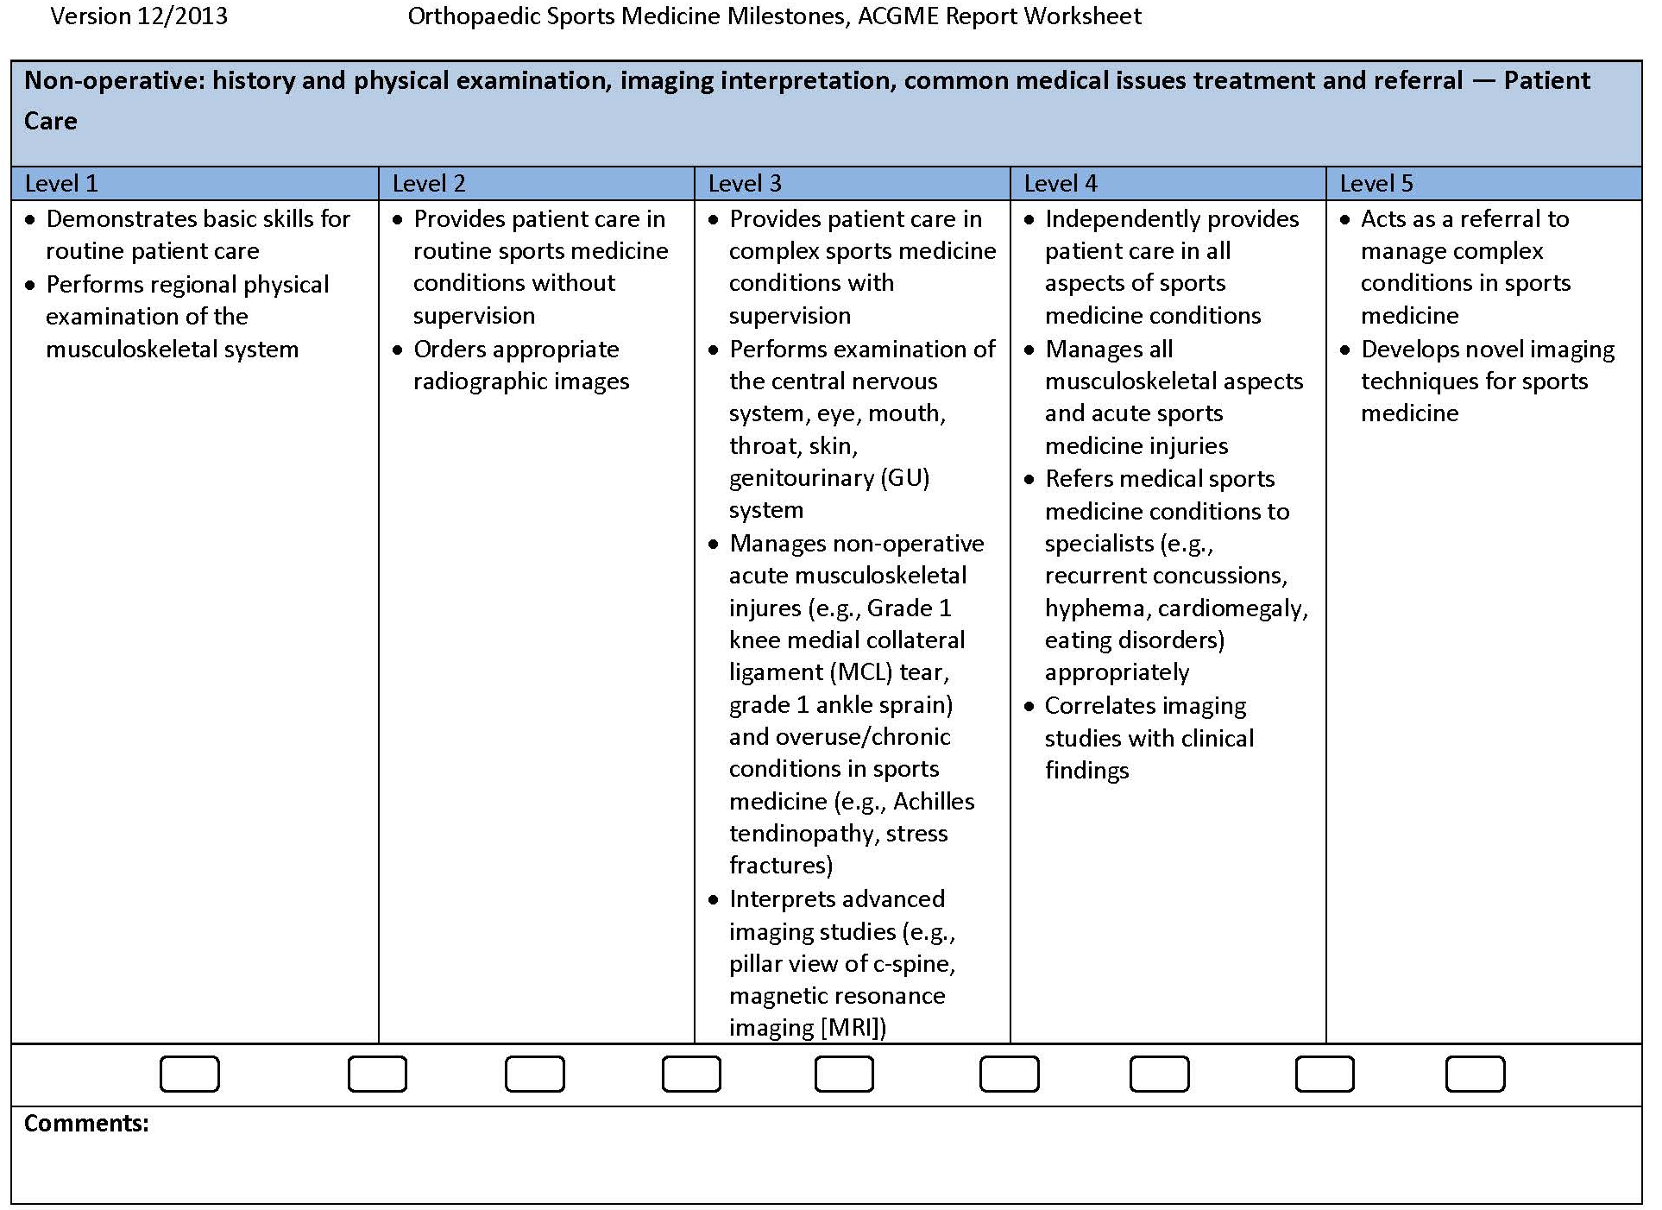

Fellow: |  |  | Attending Evaluator:
Rotation: |  |  | Date:
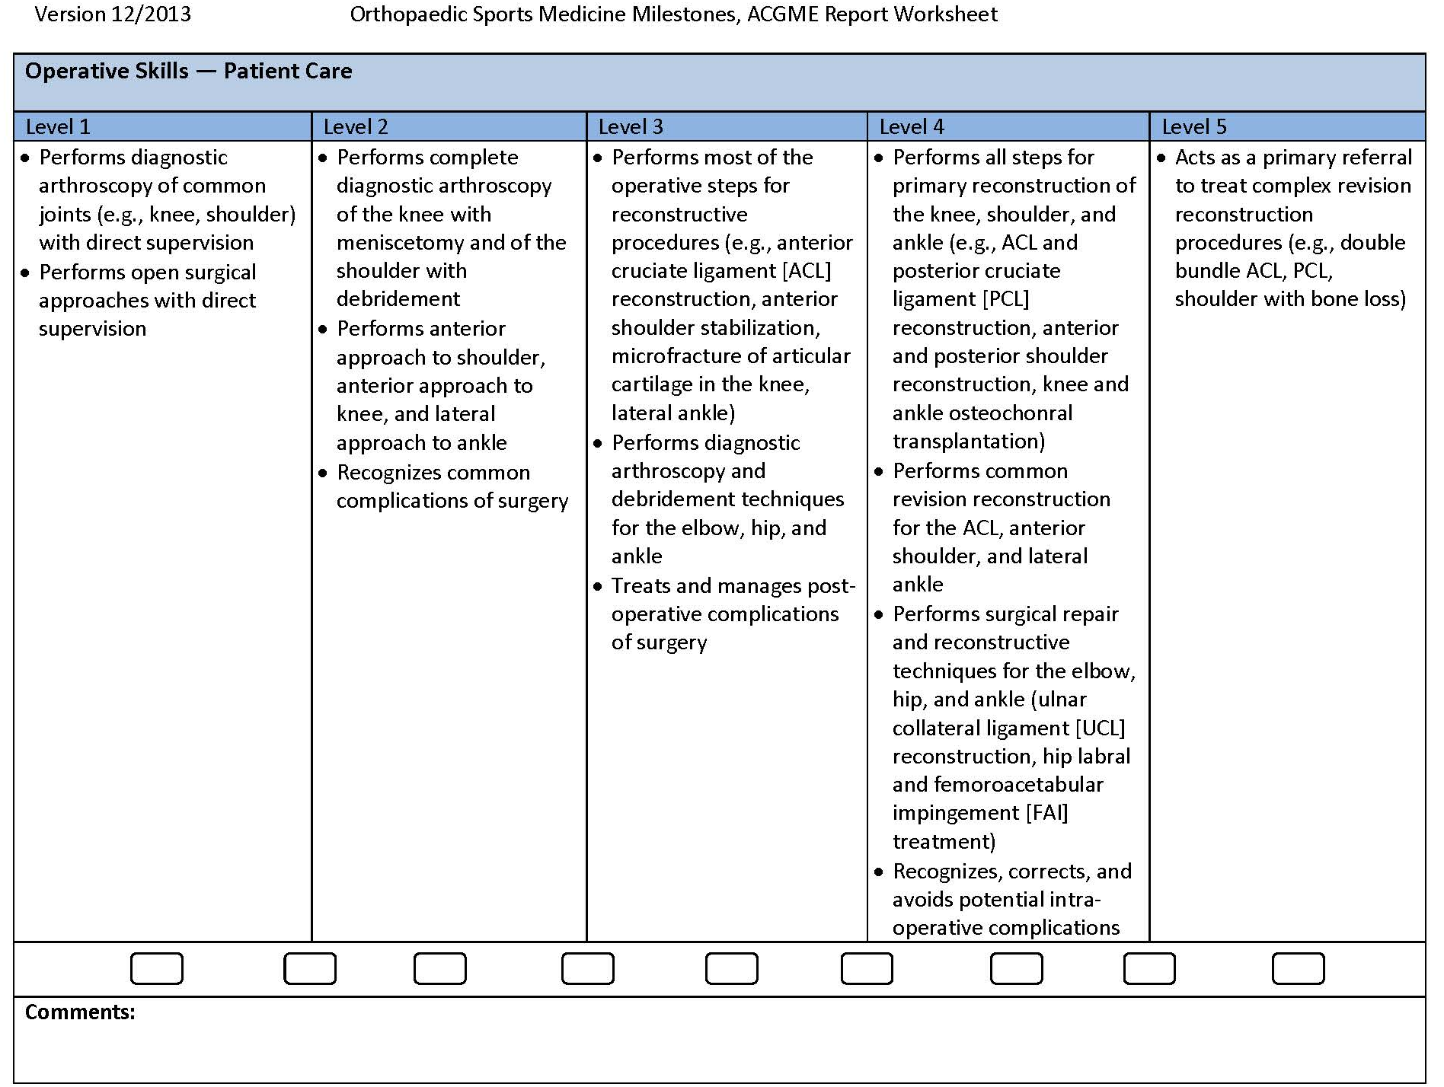

Fellow: |  |  | Attending Evaluator:
Rotation: |  |  | Date:
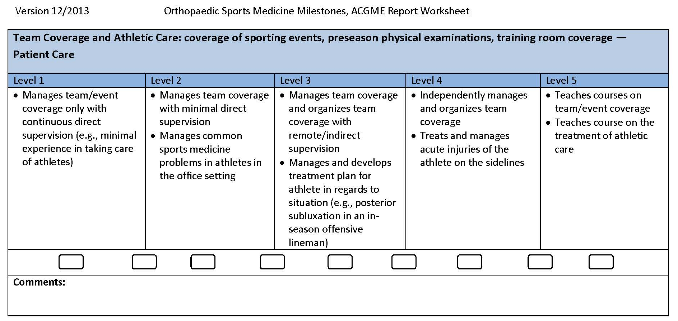

Fellow: |  |  | Attending Evaluator:
Rotation: |  |  | Date:
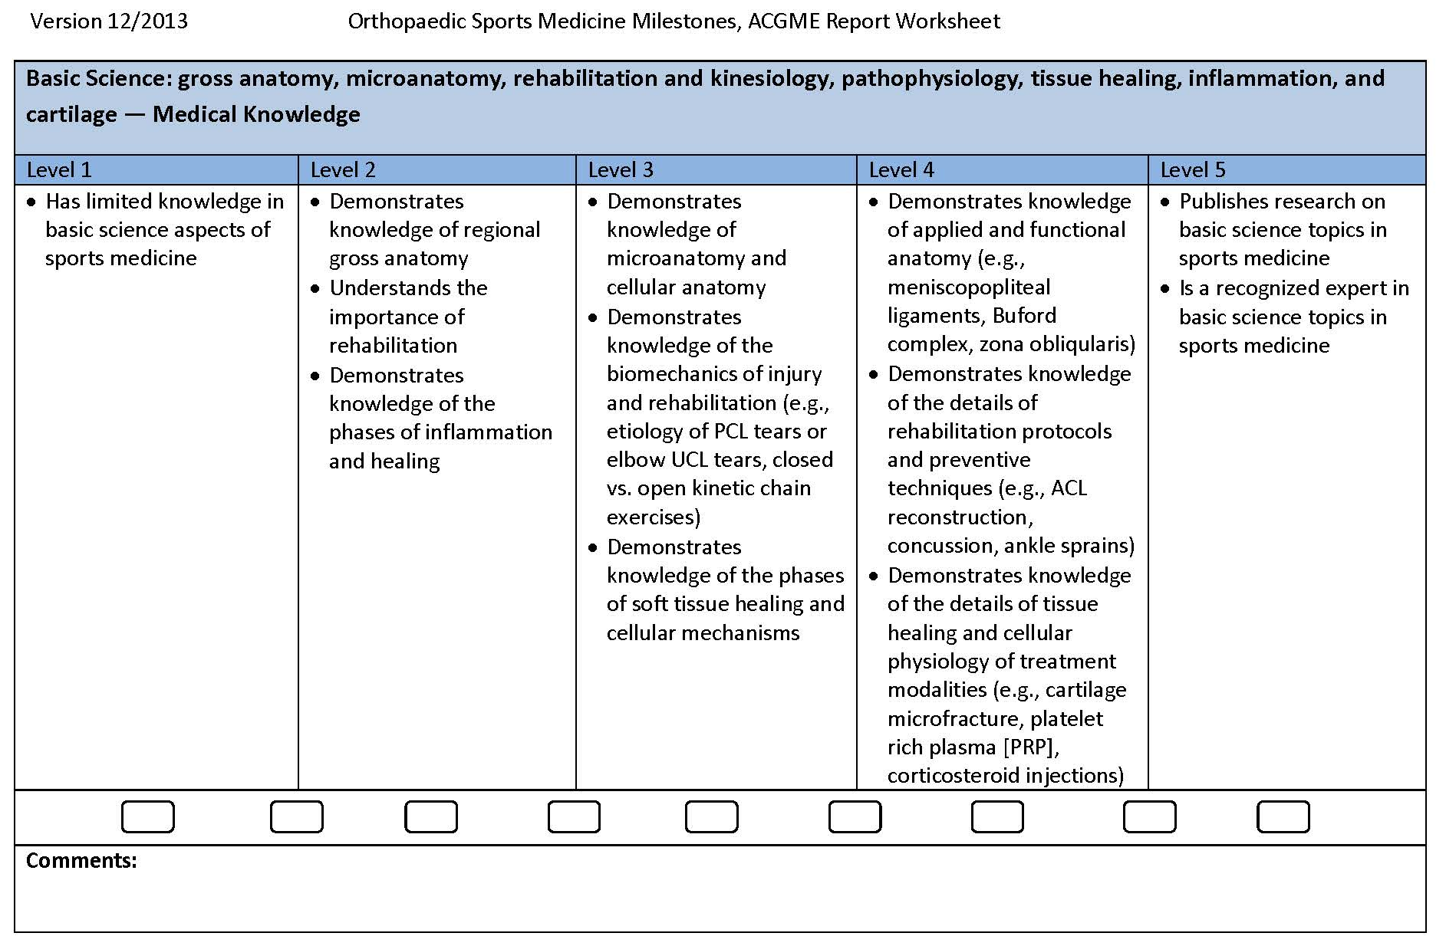

Fellow: |  |  | Attending Evaluator:
Rotation: |  |  | Date:
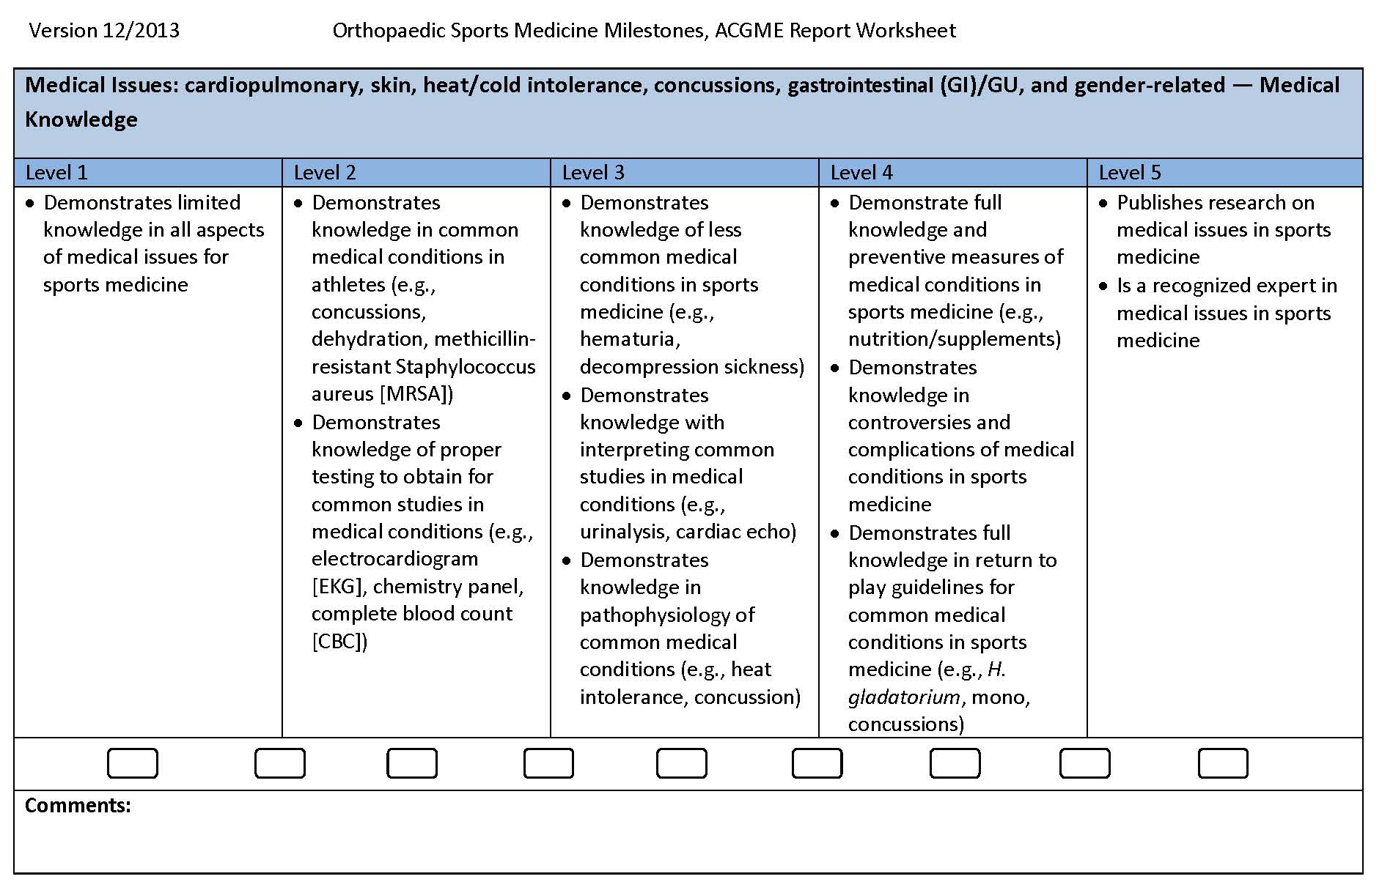

Fellow: |  |  | Attending Evaluator:
Rotation: |  |  | Date:
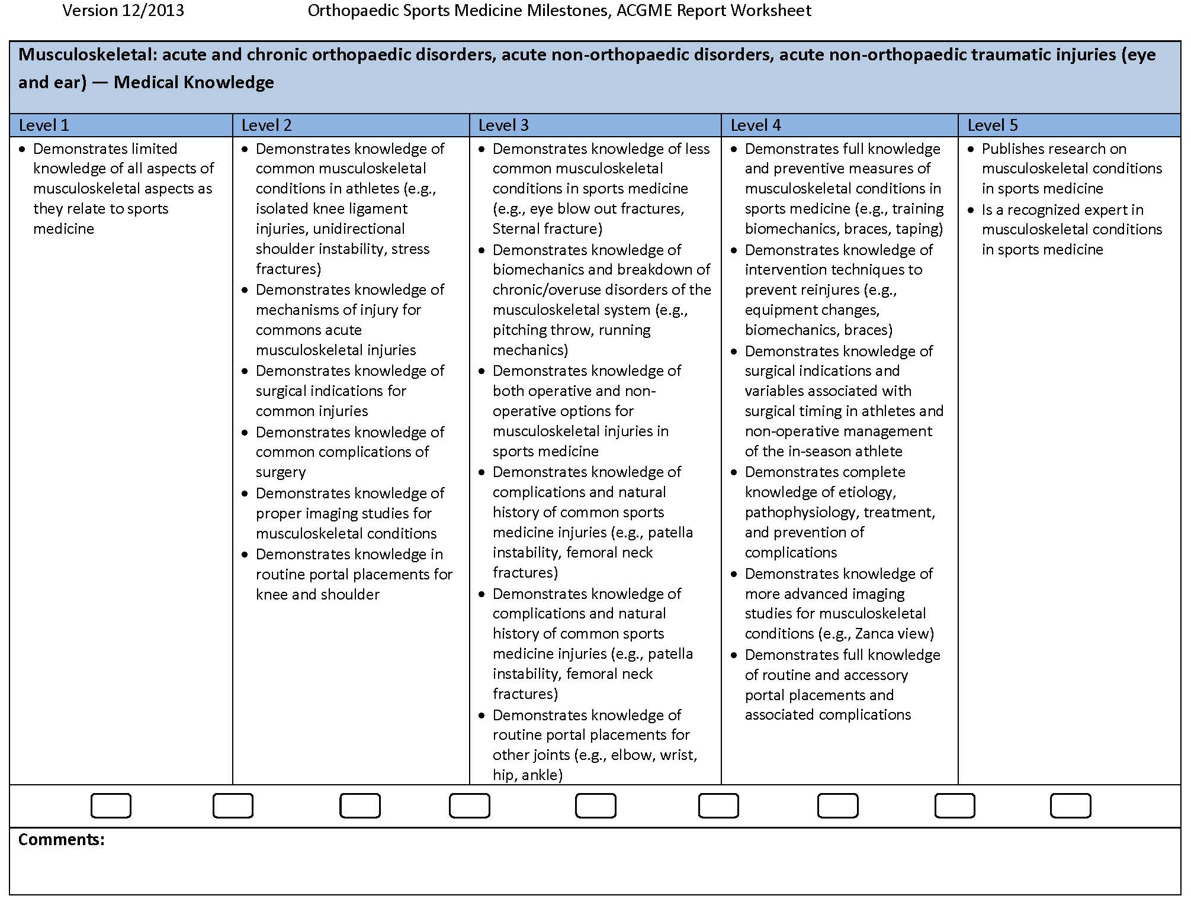

Fellow: |  |  | Attending Evaluator:
Rotation: |  |  | Date:
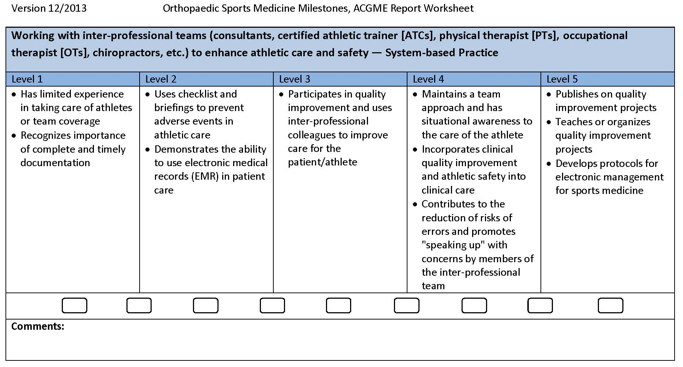

7

Fellow: |  |  | Attending Evaluator:
Rotation: |  |  | Date:
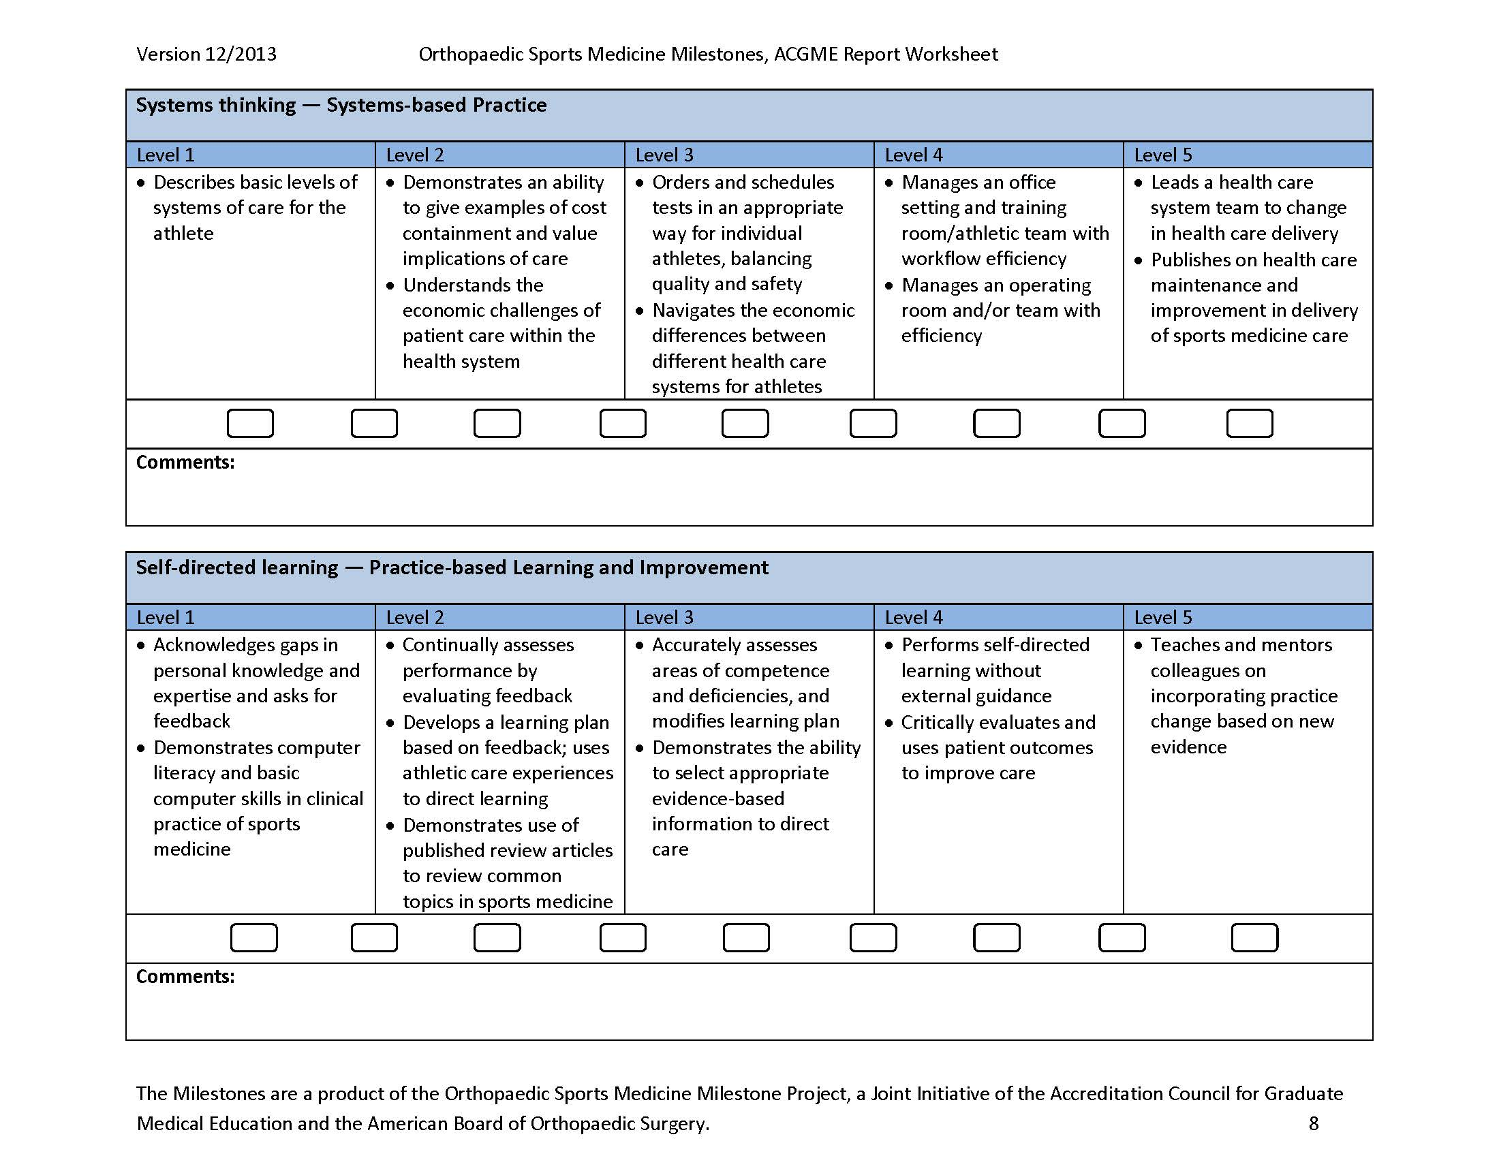

Fellow: |  |  | Attending Evaluator:
Rotation: |  |  | Date:
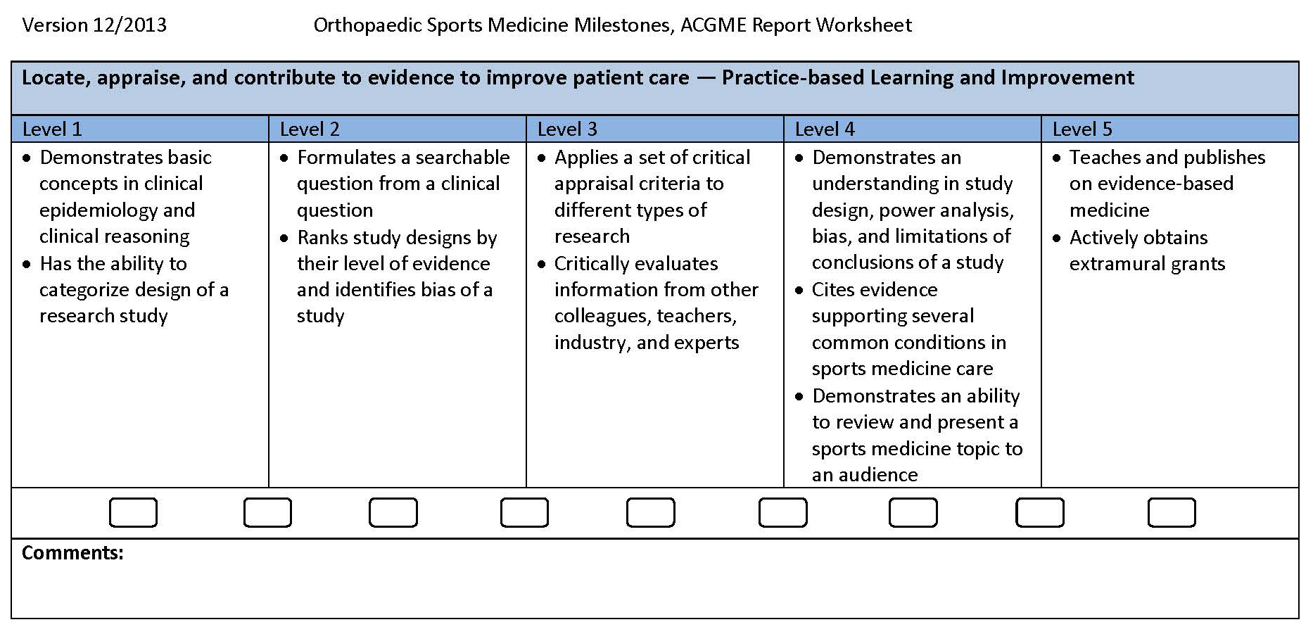

Fellow: |  |  | Attending Evaluator:
Rotation: |  |  | Date:
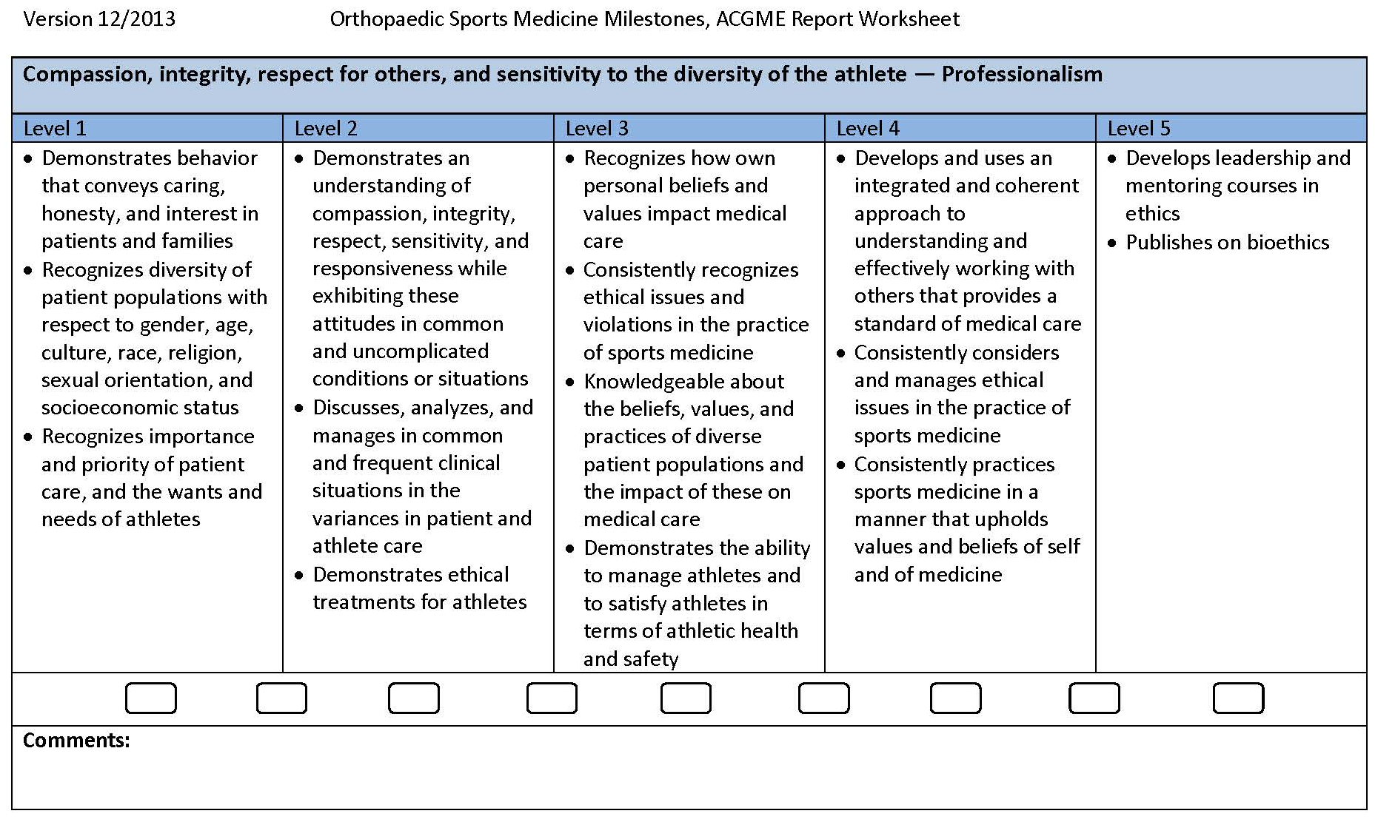

Fellow: |  |  | Attending Evaluator:
Rotation: |  |  | Date:
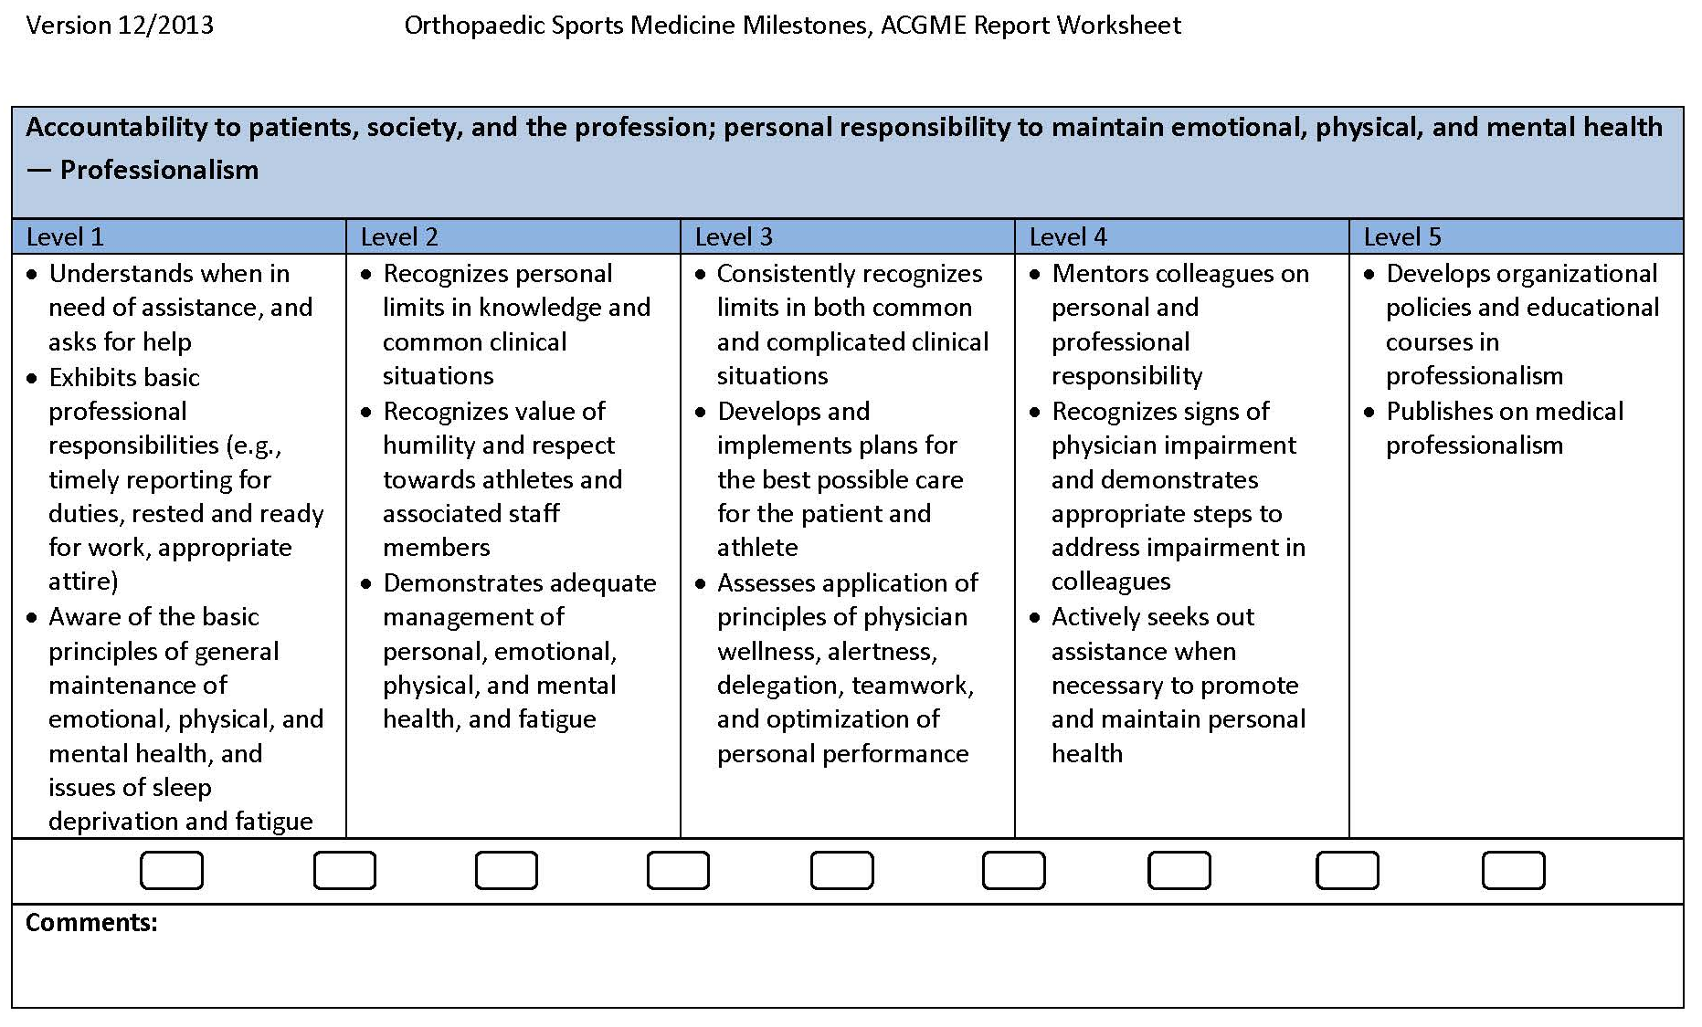

Fellow: |  |  | Attending Evaluator:
Rotation: |  |  | Date:
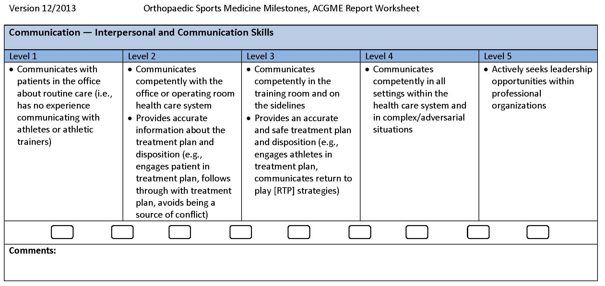

Fellow: |  |  | Attending Evaluator:
Rotation: |  |  | Date:
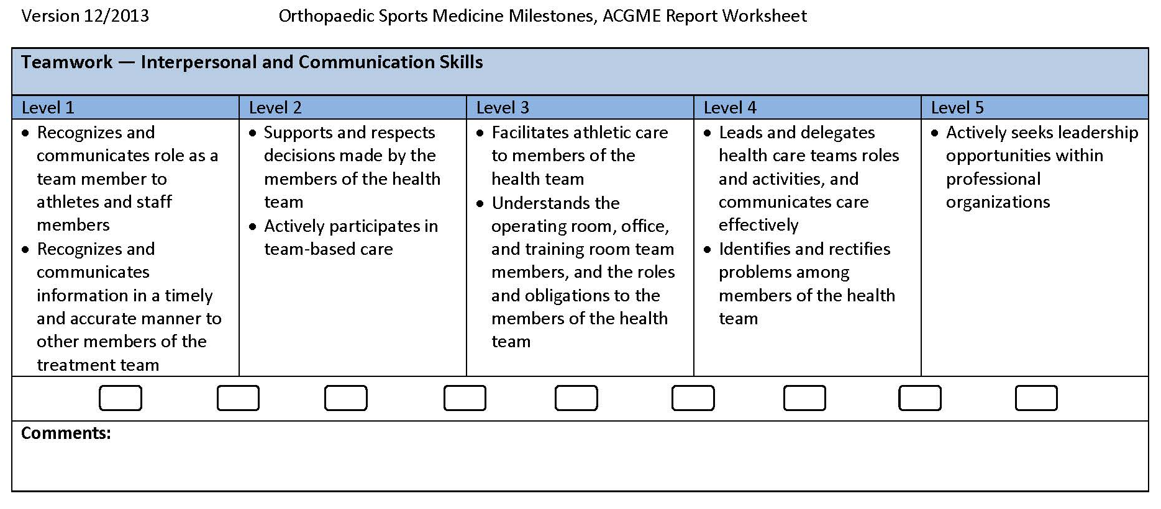

APPENDIX V

APPLICATION FOR FELLOW ABSENCE

REASON FOR ABSENCE:

Vacation: ____ Meeting: ____ Interview: ____ (3 day maximum)
NAME:______________________________________________________________________
DATES OF ABSENCE:_________________________________________________________

TITLE OF MEETING (if applicable):______________________________________________
HOSPITAL/SERVICE ABSENCE:________________________________________________
MANDATORY SIGNATURES:

_____________________________________________________________________________
Signature of Current Attending

_______________
Date

_____________________________________________________________________________
Signature of Program Director

_______________
Date

- You must have signatures of all attendings whose caseloads are affected by your absence.

- No absence will be scheduled or allowed on the electronic calendar by the Education Coordinator until ALL of the above information is complete.

- No meeting expenses will be submitted or subsequently reimbursed unless an absence request form is submitted at least 2 weeks PRIOR to the date of the meeting

